The BEARMAP mapping system

Introduction

One of the goals of BEAR project was to make a map of electrical conductivity of Northern Europe. The sources of data for this task are very different: the electrical conductivity can be measured in points (randomly distributed, placed along profiles or in nodes of rectangular grids) or given as maps of isolines. It was necessary to create a tool that can input data of all mentioned kinds, treat them in the same manner and convert the data to rectangular grids which are commonly used for numerical modelling. In addition, electrical conductivity is essentially discontinuous earth-distributed function.
The BEARMAP program was created primarily to represent and process such functions. But the program appeared to be a convenient tool for many other mapping applications: plotting vector maps in different projections, adding bitmap images to vector maps, digitizing lines and/or points from scanned maps etc.

Main features of the program are as follows:

- works under Windows 95/98/NT/XP;
- uses equidistant geographic projection or an arbitrary globe projection;
- enables to resize maps and rotate the globe easily;
- enables to plot vectorized geographic contours, unfilled, filled or textured;
- enables to load bitmaps (scanned maps), correspond them with geographic projection and plot;
- can plot data point sets (sets of points with known coordinates and values of some function) by markers;
- can plot data lines representing earth-distributed functions (isolines, profiles, borders of discontinuity);
- can recalculate functions given by data points and data lines into nodes of rectangular grids;
- can represent rectangular grids by transparent colored fields and/or isolines;
- enables 2D plot of functions given by grids.

Data presentation in BEARMAP program

There are 5 kinds of data lines implemented in the program. All of them are lines (sets of points in geographic coordinates) with some attached values.
Each data line can be attached by a depth range for which the line is valid. This enables to make maps containing several depth layers.

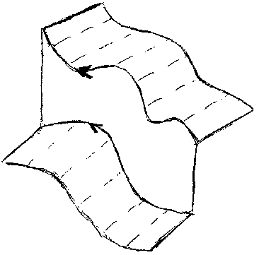  Line of discontinuity | 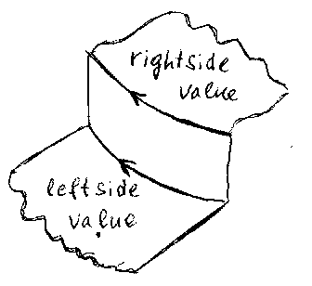  Two-side isoline
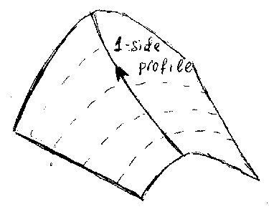  One-side profile | Two-side profile
Fig.1. Kinds of data lines

Ordinary isolines

These are lines of equal value of a function. It means that the function is continuous on this line.

Two-side isolines

Each such line is a line where a function changes this value from one constant value from the left side of the line to a different value to the right of the line. These lines are used to represent discontinuities of a function (Fig.1).

Both kinds of isolines are implemented in the program in the same way, i.e., as a sets of geographic points with 2 values (left and right) attached. If the values are equal an ordinary isoline is assumed.

Lines of discontinuity

These are lines with no numerical values attached. They represent places where a function has discontinuity (Fig.1).

One-side profiles

These are lines (sets of points in geographic coordinates) with one value attached to each point. These lines are intended to represent a smooth functions (Fig.1).

Two-side profiles.

These are lines (sets of points in geographic coordinates) with two values attached to each point. As well as lines of discontinuity, these lines are intended to represent places where a function has an abrupt break. The only difference between them is that points of such profile are characterized by some values whereas values for abrupt borders are obtained by an interpolation by surrounding isolines (Fig.1).

In addition to these 5 kinds of data lines 2 more data types are implemented: data points (randomly distributed points on earth surface with values attached) and rectangular grids.
An example of a function given by data lines of different kinds is shown in fig.2.
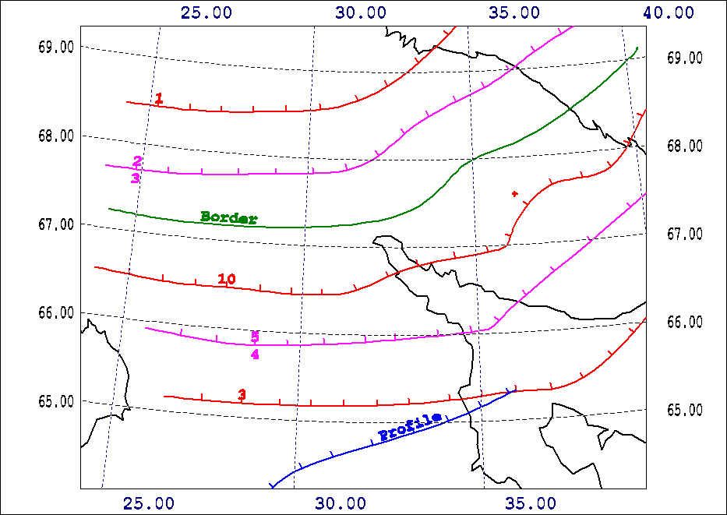
a) A function given by a set of data lines
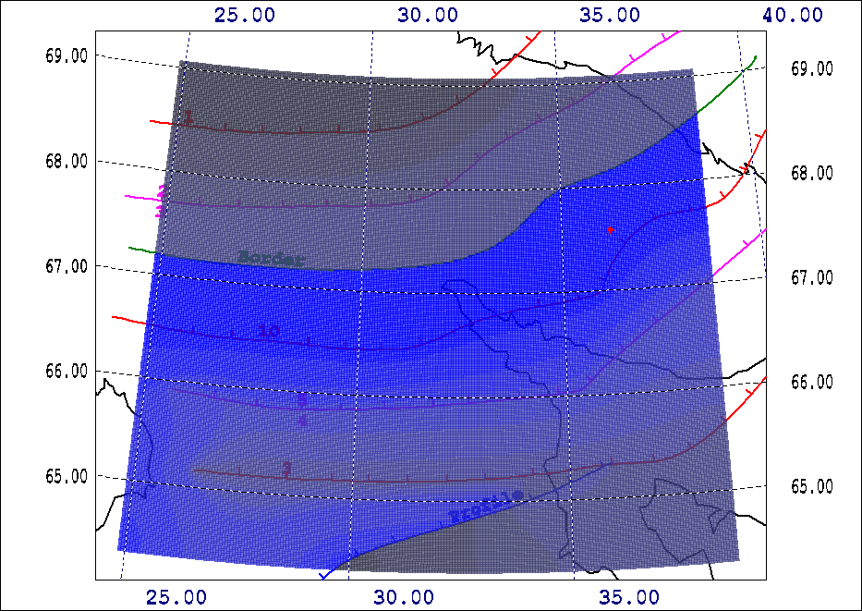
b) The function is re-calculated into nodes of rectangular grid and plotted by gradations of blue color

Fig.2. Example of function given by data lines and its recalculation into nodes of rectangular grid.
Red lines – ordinary (one side) isolines;
Magenta lines – two side isolines;

Green line – border of discontinuity;

Blue line - profile;

Calculation of grids and profiles

Two methods are implemented to recalculate data into nodes of rectangular grids. To process randomly distributed data points the back squares interpolation is used. To calculate a grid by data points and lines it is possible to use an interpolation by harmonic functions. Border conditions are computed in the grid by data lines and points and Laplas equation is solved numerically on the grid.

When a grid is calculated a line can be drawn across it and values of the function can be calculated on the line and saved in a file (Fig.3).
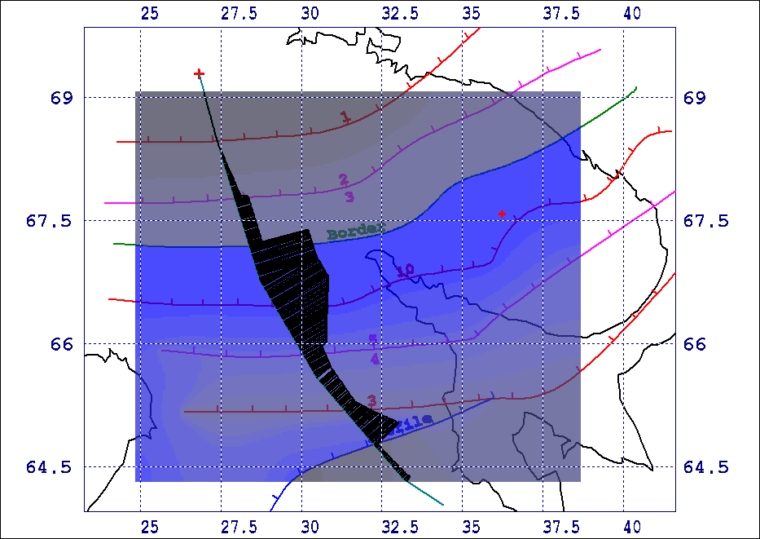
Fig.3. Profiling across a grid.

Adding bitmaps to vector maps. Digitizing lines

It is possible to load a bitmap (scanned map in a form of .BMP-file) into the program simultaneously with vector contours. User can establish a correspondence between some points with known geographical coordinates (reference points) on a vector map and points of a bitmap. When several points are linked the program computes a regression enabling to recalculate geographical coordinates for pixels of the bitmap:

λ=a₁+a₂⋅x+a₃⋅y+a₄⋅x⋅y+a₅⋅x⋅x+a₆⋅y⋅y+a₇⋅x⋅x⋅y+a₈⋅x⋅y⋅y+a₉⋅x⋅x⋅x+a₁₀⋅y⋅y⋅y
ϕ=b₁+b₂⋅x+b₃⋅y+b₄⋅x⋅y+b₅⋅x⋅x+b₆⋅y⋅y+b₇⋅x⋅x⋅y+b₈⋅x⋅y⋅y+b₉⋅x⋅x⋅x+b₁₀⋅y⋅y⋅y

where (ϕ,λ) – latitude, longitude, (x,y)-pixels of the bitmap, a,b – regression coefficients.
After that the bitmap can be plotted on the vector map in true geographical coordinates.
The process of wrapping a bitmap on a vector map is shown in Fig.4.

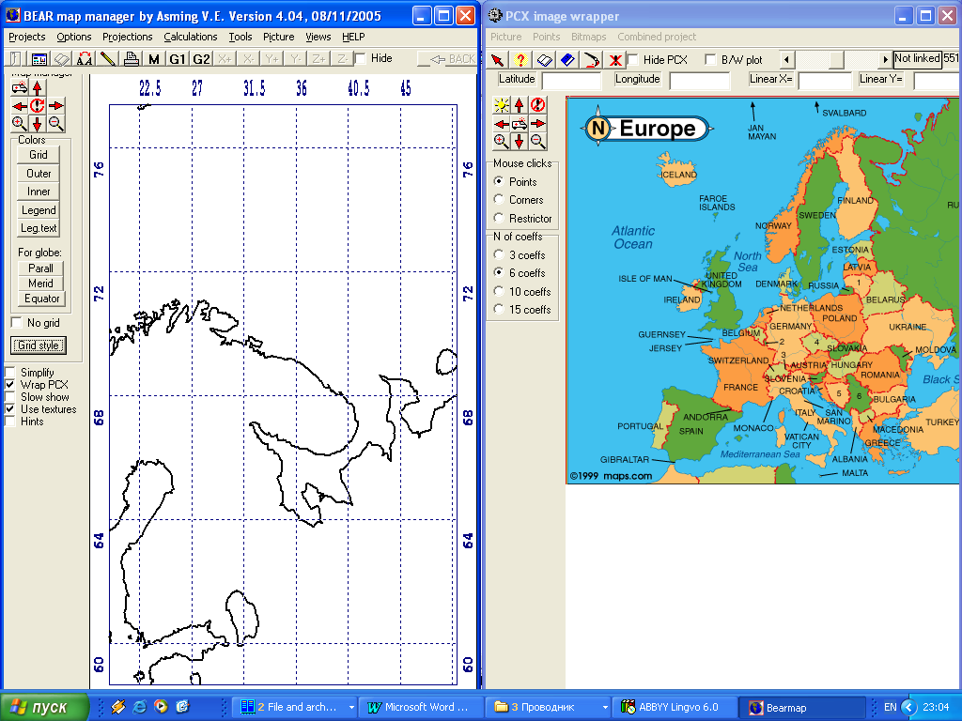
a) Establishing a correspondence between a scanned map (right) and a vector map (left) by reference points
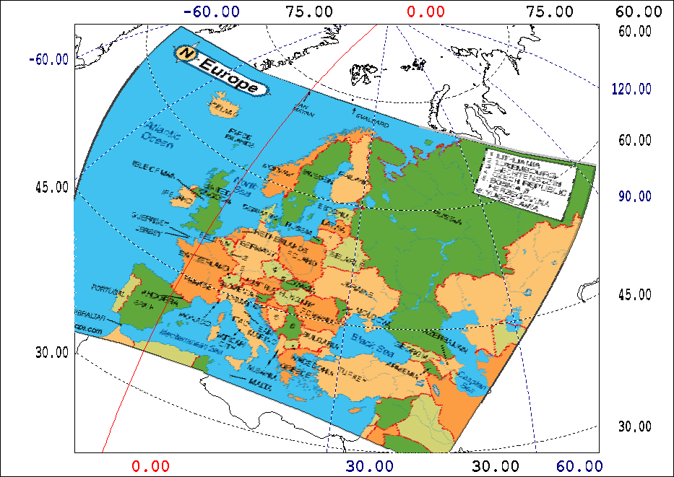
b) The bitmap is wrapped on the vector map

Fig.4. Establishing a correspondence between a bitmap and a vector map in true geographical coordinates (a) and plotting the bitmap together with the vector map.

This tool enables to use maps that were made even without coordinate grid or with distorted grid (the most part of Soviet maps), or maps made in different datums.
The BEARMAP program contains a digitizing tool. It enables to trace a line on a map by clicking mouse in its points. Together with the wrapping tool described above it makes easy to digitize lines from paper maps. Associate them with true coordinates first and trace lines second.

Usage of the program in different fields

Made for geoelectrics, the program appeared to be a convenient tool for many other mapping applications as a simple and easy-to-use GIS (later versions of BearMap were added by a search subsystem for data items). Thus, for instance, the program is in use in Institute of Water Problems to plot maps of pollutions. It is also in active use in Kola Regional Seismological Center (maps of seismicity, location of seismic events, seismic stations etc., see Fig.5)
To get more details about the program and download it visit home page of Kola Regional Seismological Center located at http://www.krsc.ru
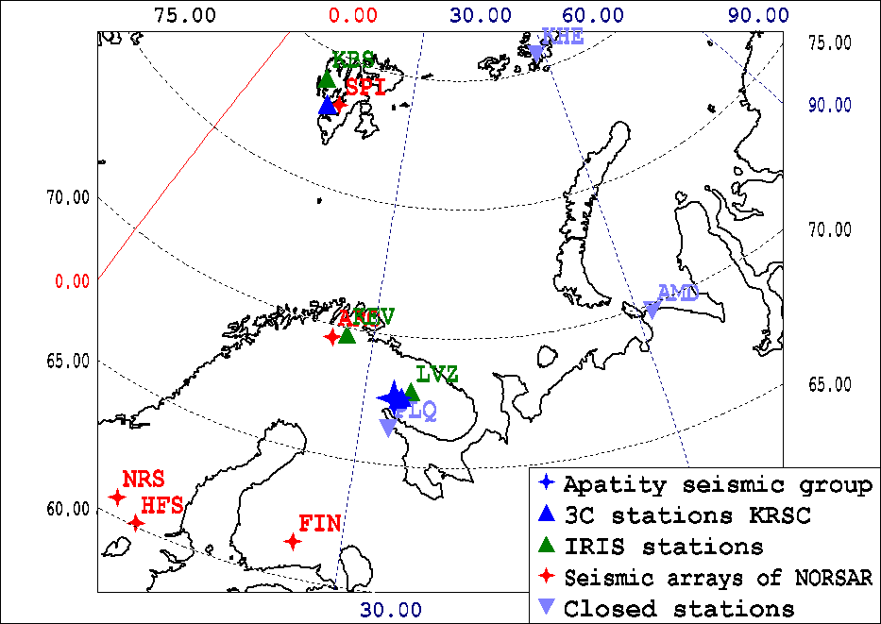
Fig.5. Map of seismic stations of Northern Europe made by BearMap

